Experiment No: 8
Aim: Events and Validations in AngularJS.

Theory:

AngularJS Events
AngularJS includes certain directives which can be used to provide custom behavior on various DOM events, such as click, dblclick, mouseenter etc.
The following table lists AngularJS event directives.
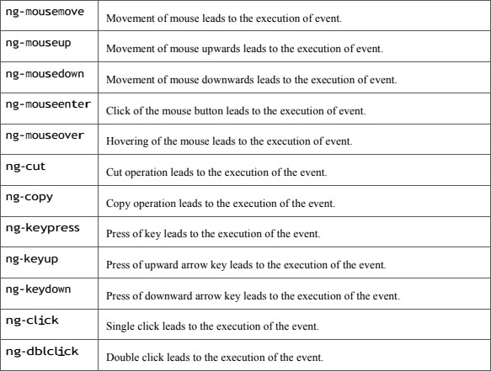

Angular Validation
AngularJS performs form validation on the client-side. AngularJS monitors the state of the form and input fields (input, text-area, select), and notify the user about the current state. AngularJS also holds information about whether the input fields have been touched,modified, or not.

Form input fields have the following states :
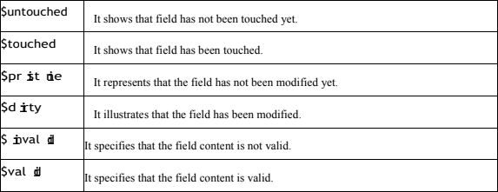

These all are the properties of the input field which can be either true or false. Forms have the following states:
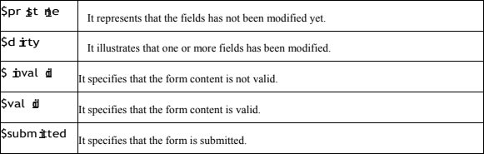
These all are the properties of the form which can be either true or false. These states can be used to show meaningful messages to the user.

Code:
<!DOCTYPE html>
<html>
<head>
<script src="https://ajax.googleapis.com/ajax/libs/angularjs/1.8.2/angular.min.js"></s cript>
<link rel="stylesheet" href="style.css" />
</head>

<body>
<div class="app" ng-app="napp" ng-controller="myCtrl">
<form name="form1">
<div class="form-control">
<label for="name">Name</label>
<input ng-required="true" id="name" name="name" type="text" ng model="name" />
<span class="error" ng-show="form1.name.$touched && form1.name.$error.required"
>Name Required</span>
</div>
<div class="form-control">
<label for="username">Username</label>
<input class=""
ng-required="true" name="username" id="username" type="text"
ng-model="username"/>
<span class="error" ng-show="form1.username.$touched && form1.username.$error.required"
>Username Required</span>
<div class="form-control">
<label for="phone">Phone Number</label>
<input
ng-required="true" ng-minlength="10"

ng-maxlength="10"
tel="phone"
type="tel" name="phone"
ng-model="phone">
<span> class="error"
ng-show="(form1.phone.$touched && form1.phone.$error.required ) || form1.phone.$error.minlength || form1.phone.$error.maxlength"
>Phone Number Must be 10 digits</span>
</div>
<div class="form-control">
<label for="email">Email</label>
<input ng-required="true" name="email" id="email" type="email" ng model="email" />
<span class="error"
ng-show="(form1.email.$touched && form1.email.$error.required) || form1.email.$error.email"
>Valid email is required</span>
</div>
<div class="form-control" style="width: 95%">
<label for="passwod">Password</label>
<input
ng-required="true" id="passwod" name="password"

type="{{showPassword ? 'text' : 'password'}}" ng-model="password"
ng-pattern="/^(?=.*\d)(?=.*[a-z])(?=.*[A-Z])(?=.*[a-zA-Z]).{8,}$/" <span>

class="error"
ng-show="(form1.password.$touched && form1.password.$error.required) || form1.password.$dirty && form1.password.$error.pattern"
>Password must contain at least 8 characters, one lowercase letter, one uppercase letter, and one number</span>
</div>
<div class="chk">
<input id="showPassword" type="checkbox" ng-model="showPassword" /> <label for="passwod">Show Password</label>
</div>
<button
ng-disabled="form1.$invalid" ng-show="!form1.$invalid" type="submit" class="btnSubmit"
ng-click="print()
</button>
</form>
</div>
<script>
var app = angular.module("napp", []); app.controller("myCtrl", function ($scope) {

$scope.print = () => { alert("Submitted");
};
$scope.copyText = (userInput) => { console.log(userInput);
};
});
</script>
</body>
</html>
Output:
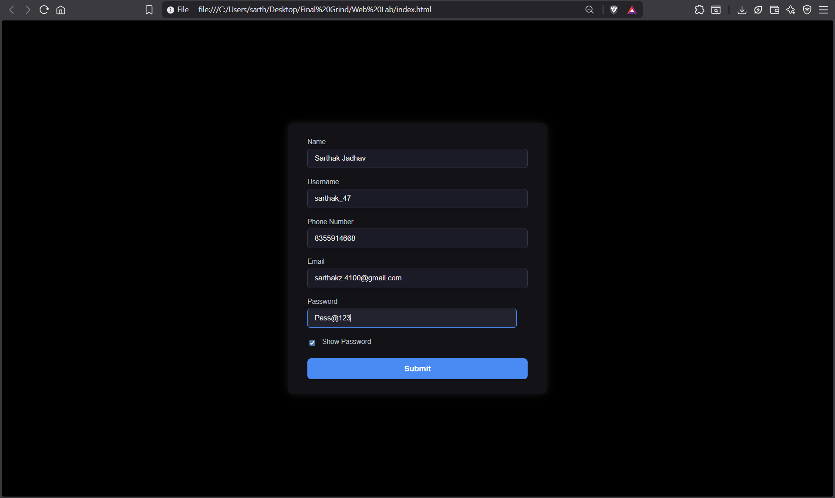

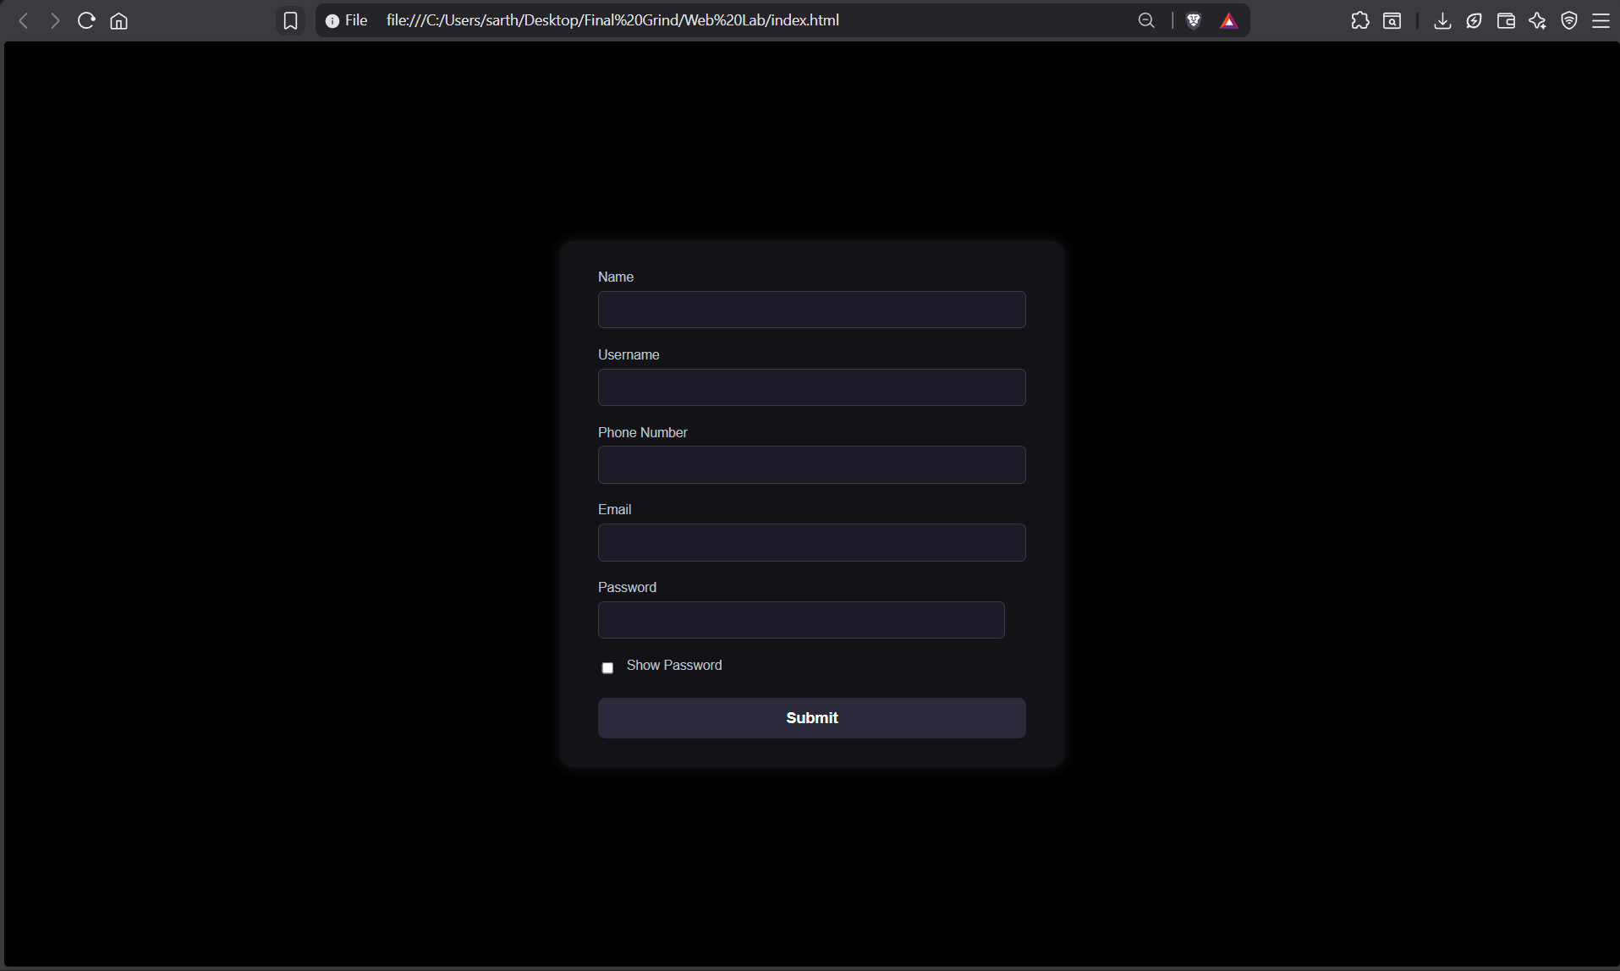
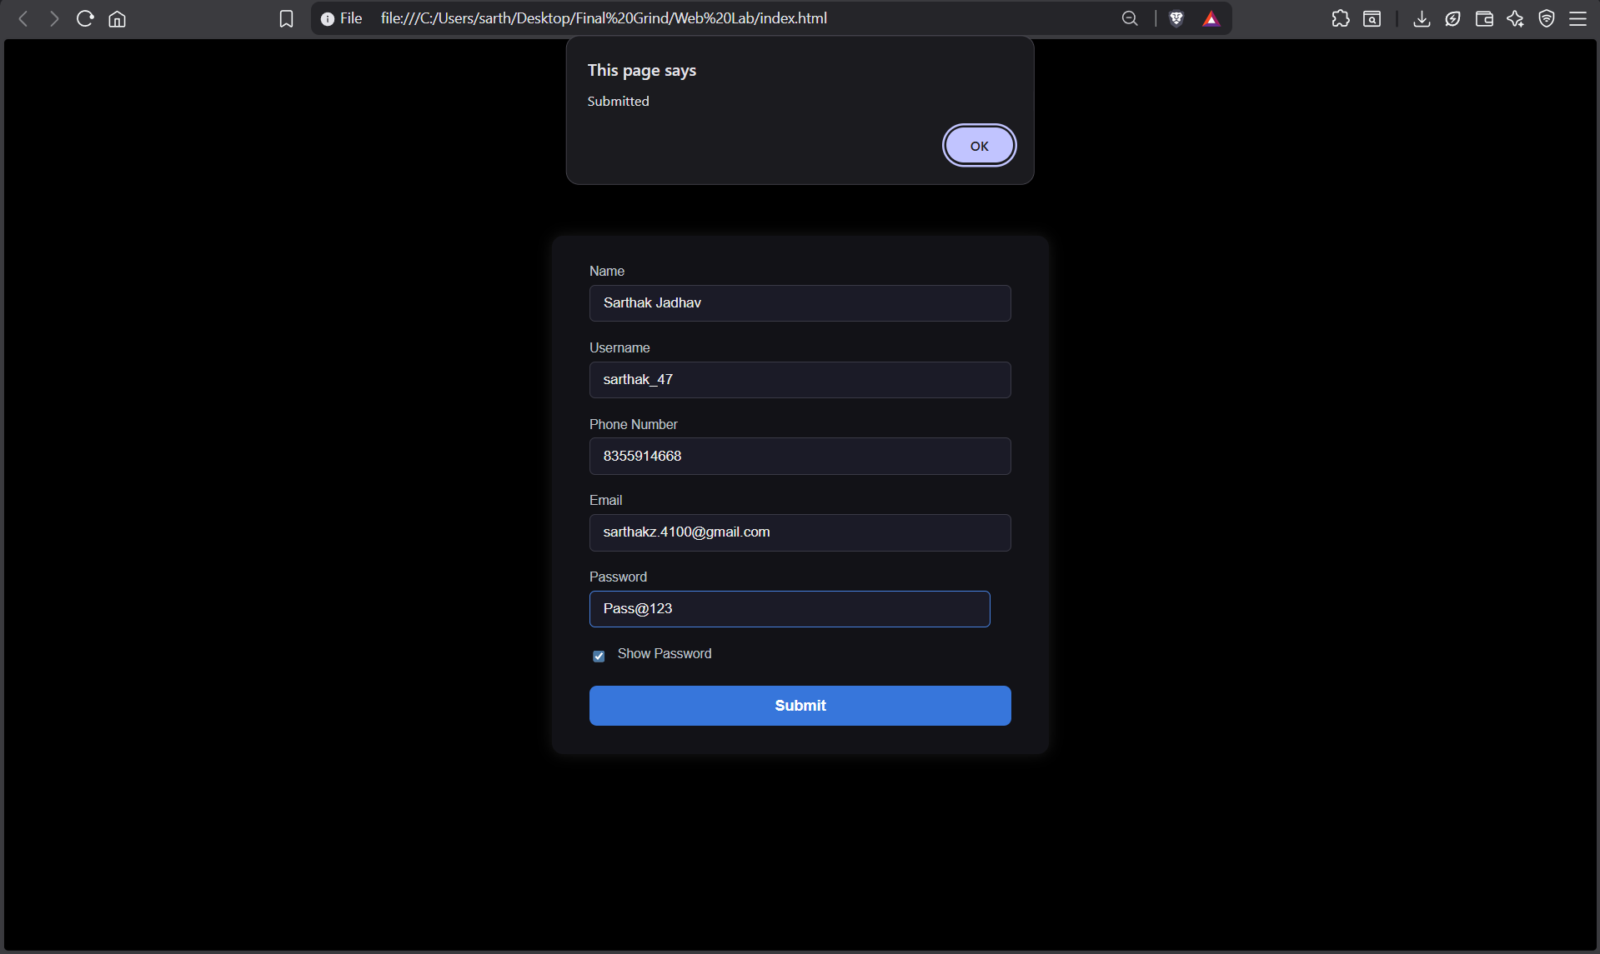

Conclusion:
Handling events and implementing form validation in AngularJS ensures a seamless user experience and data accuracy. Using Angular’s built-in directives like $valid enhances form validation without requiring additional JavaScript logic. This experiment strengthens skills in creating responsive and error-free forms.

